SELECT A1.id, A1.nombre, A1.telefono, A2.id_contacto, A2.numero_likes FROM contacto A1, contacto_likes A2 where A1.id = a2.id_contacto order by A2.id_contacto

EL BUENO

SELECT A1.id, A1.nombre, A1.telefono, A2.id_contacto, SUM(A2.numero_likes) FROM contacto A1, contacto_likes A2 where A1.id = a2.id_contacto GROUP BY A2.id_contacto ORDER BY SUM(A2.numero_likes) DESC

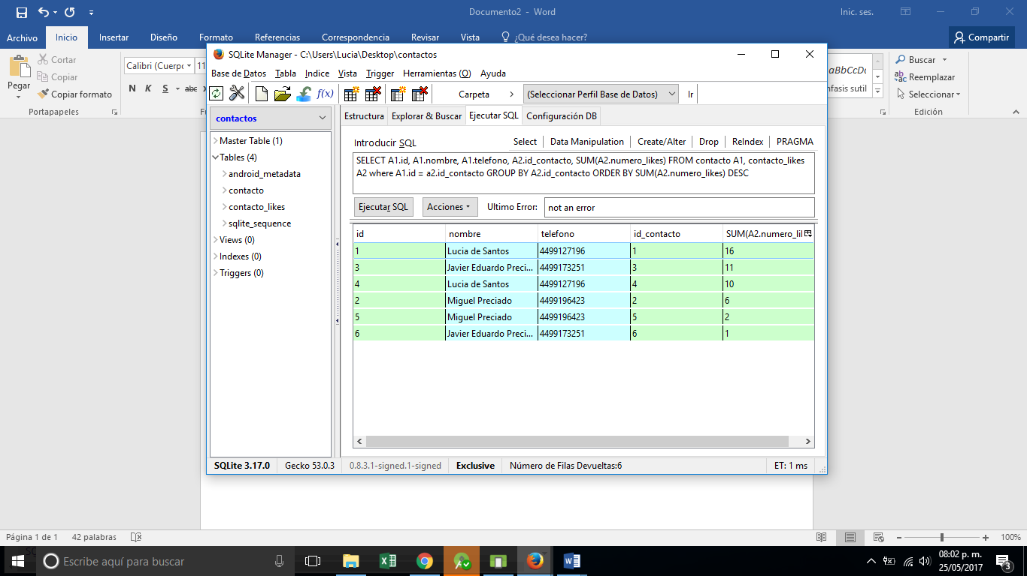

SELECT A1.id, A1.nombre, A1.foto, A2.id_mascota, SUM(A2.numero_likes) FROM mascota A1, mascota_likes A2 where A1.id = A2.id_mascota GROUP BY A2.id_mascota ORDER BY SUM(A2.numero_likes) DESC